LAB Logbook

Lab 1

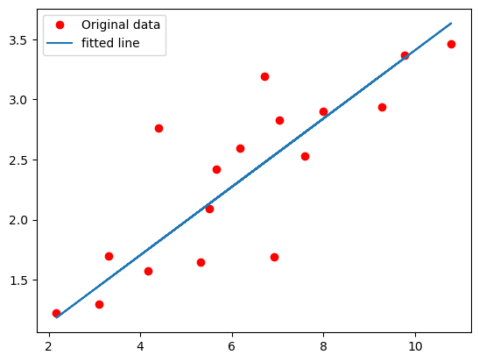

Lab 2

Lab 3

Lab 4

Lab 5

Lab 6

Lab 7